**Project Report**

***TATA IPL Auction List Data Analysis***

**Name** :- *Swati Sambhaji Patil*

**Project Name** :- *TATA IPL Auction List Data Analysis*

**Date** :- *4 December 2024*

**Technology** :- *Language “ Python”*

**Library** :- *NumPy, Pandas, Matplotlib, Seaborn*

## Project Description

IPL 2025 Auction List - Comprehensive Player Data

This dataset provides detailed information about the TATA IPL 2025 player auction list. It includes a players specialisms, past performance statistics, previous IPL teams, and reserve prices of current team players. The data is ideal for cricket enthusiasts, and analysts, looking to explore trends, predict team composition, and analyze player values.

## Background:

The Indian Premier League (IPL) is one of the most significant cricket leagues globally. Every year, teams participate in an auction to select players for the upcoming season. The IPL Auction process has become increasingly data-driven, with teams using sophisticated methods to select players who will contribute to their success. Analyzing the data from these auctions helps identify trends, and patterns, and forecast future player performance.

## Data Dictionary:

* **Player Information**

=> Test, ODI, and T20 caps, along with specific roles like batter, bowler, all-rounder, and wicketkeeper.

* **Player Statistics:**

=> Test, ODI, and T20 caps, along with specific roles like batter, bowler, all-rounder, and wicketkeeper.

* **Previous IPL Experience**:

=> A history of players' past IPL teams and their performances in previous seasons.

* **Special Skills:**

=> Detailed info on batting and bowling styles (e.g., RHB, LHB, off-spin, fast medium).

* **Reserve Prices:**

=>Each player's base price for the 2025 auction, listed in lakhs (INR).

## Key Objectives:

* **Team Composition Analysis:**

Useful for examining potential team strategies and picking the best players based on performance history and reserve prices.

* **Auction Trends:**

Investigate player reserve prices to identify market trends, budget allocation, and potential bids.

* **Performance Insights:**

Includes the number of matches played across formats, allowing for analysis of experience and specialization.

## Potential Insights:

* **Data Analysis:**

Compare player statistics, analyze historical performance, and predict auction outcomes.

* **Cricket Predictions:**

Use the data to forecast the success of different teams based on auction selections.

* **Fantasy League Strategies:**

Build the optimal fantasy team by studying player skills, previous records, and auction prices.

# Additional Sections for Project Report

## Methodology

**Data Acquisition:**

* **Official IPL Auction Data**:available on the IPL website, including player details like nationality, performance, and bids
* **News Articles and Auction Summaries** :gathering team strategies and comments from experts
* **Historical Auction Data** :to compare trends from previous seasons

**Data Cleaning and Preprocessing:**

* Missing values were found for some players' performance statistics

**Data Exploration:**

* Indian Country has most player in IPL Auction 2025.
* The average age of players was found to be 28 years, with the age range spanning from 19 to 40.
* Older players are valued higher due to experience or past performances.

**Key Visualization:**

* Histogram shows the age distribution of players.
* Indian Country has most player in IPL Auction 2025.
* Older players are valued higher due to experience or past performances.

**Future Work :**

* **Additional Analysis:** Incorporating player injury history and fitness levels into future analyses could enhance the predictive capabilities of auction prices.
* **Data Enrichment:** Expanding the analysis to include IPL performance after auction and post-season impact could provide a clearer link between auction spending and team success.
* **Technological Advancements:** Discuss potential applications of emerging technologies (e.g., machine learning, artificial intelligence) in future research.

# Project Snapshot

1. **This graph shows distrution of players Age(using histogram)**

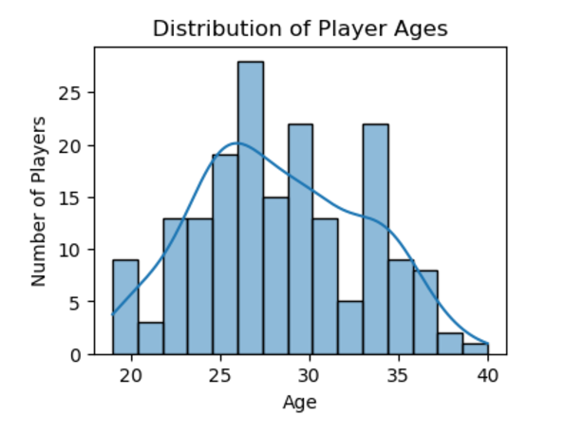

1. **This graph shows how many players are there from each country .**

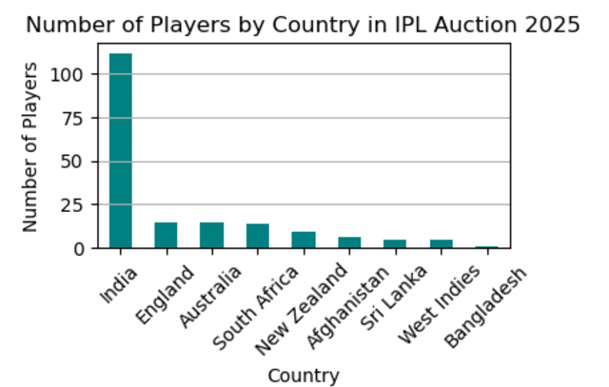

1. **This graph shows how the reserved price depends on age(using scatter graph)**

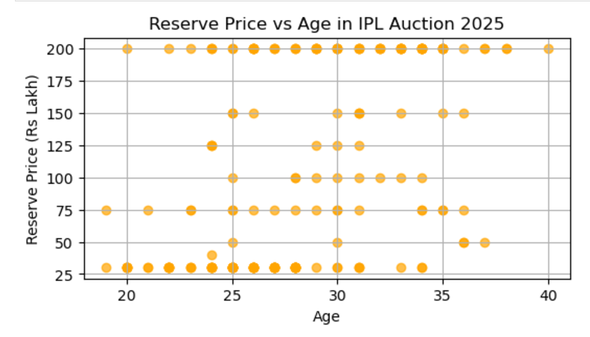

**4.This graph shows names of players who has highest reserve price(using bar graph)**

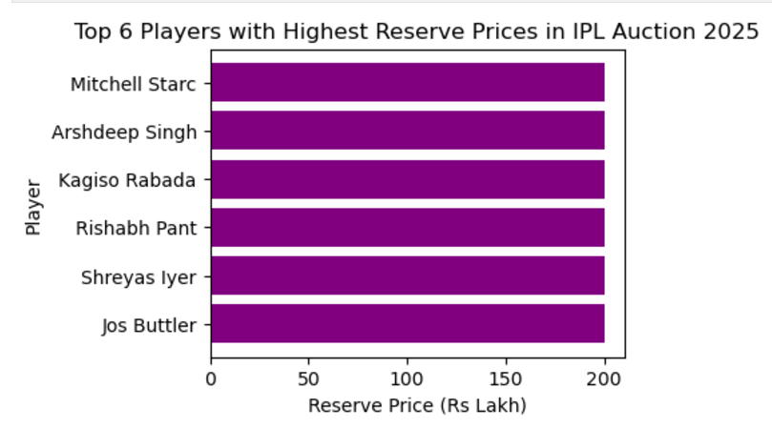

**5.This graph shows which skill is more in demand(using pie graph)**

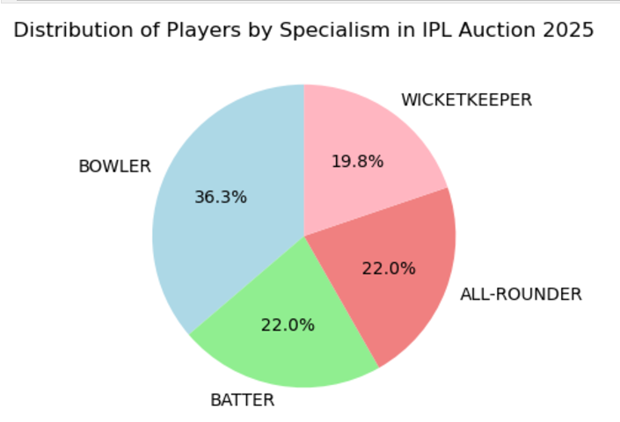

**6.From this graph shows Top % countries with highest Average reserve price (using bar graph )**

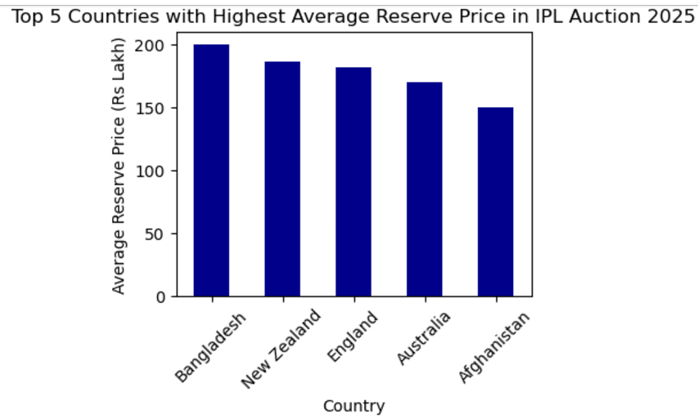

**7.From this graph you can see the number of capped players are more in IPL Auction**

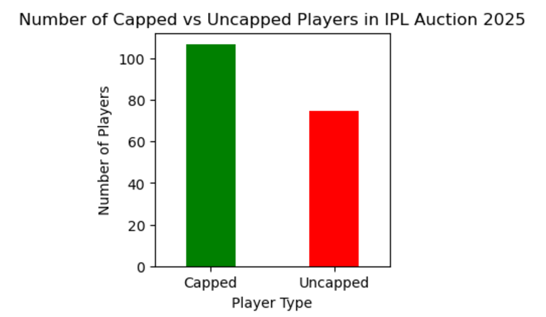

**8.From this graph we can see Batting side distribution**

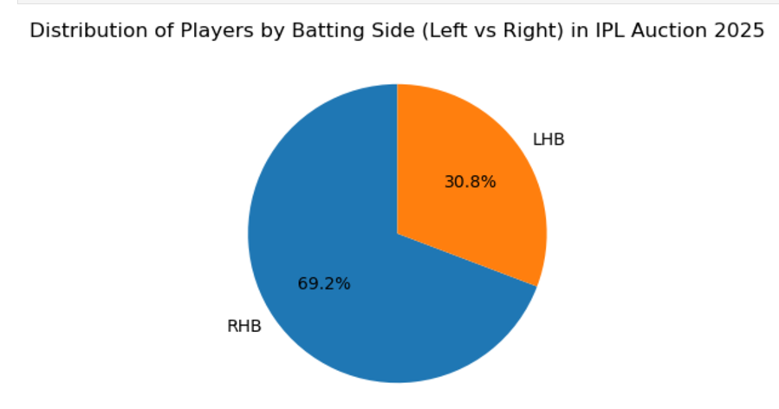

**Conclusion :**

This analysis of IPL Auction 2025 revealed that player performance, age, and nationality are key drivers of auction prices. Teams with smaller budgets target uncapped players and emerging talent. The data shows a clear trend toward valuing bowlers and younger players, which could be indicative of team’s focus on long-term value. The predictive model developed can help teams make more informed decisions based on historical trends.